

**Bachelor of Science in Computing**

**(Level 7 NFQ)**

**Year 2 – Semester 2**

**April 2024**

**BSC20923 / EPITA0124 – Object-Oriented Programming**

Internal Examiner: John Rowley

Internal Moderator: Bernard J. Roche

External Examiner: Maria Barry

Date: 23/04/2024

Time: 14:00-16:00

Examination Method Computer

**Instructions**

1. This paper consists of two sections:

* Section A is **compulsory** and contains 1 question with two parts. Total marks for Section A is **40** marks.
* Section B has 3 questions. You must attempt any **2** questions. Each question is worth **30** Marks.

1. Create a Blank Solution File and create a project for each question place each project within the main solution file. Your solution file should be called **oop-exam-<student no>.sln**. Each project file shold be named question-1, question-2 etc. Where you are asked to write a description, use Word and put your file inside the project.
2. Solutions that do not compile will be marked at 50% of the original mark.
3. You must ZIP (no other format will be accepted) your code. As a backup, you should commit your code to a private repository and share to JohnAtDorsetCollege – add the link in the moodle submission. Allow ten minutes at end of exam for uploading zip files.
4. All code files / text answers must contain your name and student number.

**SECTION A (COMPULSORY)**

**Question 1 (Compulsory)**

1. What does it mean to declare a class sealed?

A sealed class can’t be inherited, its used to restrict the inheritance feature of OOP. A sealed class is created using the sealed modifier.

(5 marks)

1. A local college has several buildings in city centre. Each building has its specific door code to enter in the building. The administration of the college wants to show all the door codes in a console program.   
     
   You are required to develop the following:  
   1. A class named BuildingCodes with the following properties:   
      Building Id, Building Location,   
      Building Code. Building Id is a numeric field. Building Code is alphanumeric and is between 4 and 6 characters long. Building Location is a string – maximum length is 20 characters. All fields are required.   
       (5 marks)
   2. Store all the details in an appropriate collection .   
       (5 marks)
   3. Initialise the data with 10 examples of mock data using an appropriate Nuget package for faking data.   
       (5 marks)
   4. Develop an interactive console to the list the buildings in Ascending or Descending order (sort by building id).   
       (10 marks)
   5. Add interactive console commands to add new building data to the existing list. When you add a new building, the program should list all the buildings in ascending order (based on BuildingId).

(10 marks)

(Total: 40 marks)

**SECTION B**

**Question 2**

Write notes on any **three** of the following terms:

1. Inheritance

When a class is created from another class. The new class inherits all the methods and properties of the parent class.

You would use it when you want to create a new class that is similar to an existing class, to reuse code of existing class

1. polymorphism

It’s the ability of an object to take on many forms.

It is use to derived class object as base class object

1. static member variables and methods,
2. interfaces, and
3. abstract classes.

Your answer should include an explanation of each term (5 mark), example of its use (3 marks) and an explanation of when you would use it (2 mark).

Submit this as a Word document or PDF. Other formats will NOT be marked. It should be named **question-2-<your-student-number>.**

(3 * 10 marks)

(Total 30 marks)

**Question 3**

Implement a class called Movie, whose constructor and public methods are listed in the table below. Each movie has attributes: name, rating, running time, and director

|  |  |  |
| --- | --- | --- |
| Method | Description / specification | Marks |
| movie(….) | Constructor that takes various parameters to initialise the class | 4 |
| name() | Returns name of the movie | 2 |
| Director() | Returns the name of the director | 2 |
| rating() | Returns the rating of the movie | 2 |
| runningTime | Returns the running time of movie in HOURS and minutes | 2 |
| setRating() | Modifies the rating of the movie. Valid ratings are: G,PG,PG-13,R,NC_17. If an invalid rating is provided, the rating is set to NC_17 by default | 2 |
| setRunningTime() | Sets the running time in MINUTES | 2 |
| toString() | Returns a string representation of an instance of a movie | 4 |

(20 marks)

1. Write a code fragment that creates three instances of your Movie class and outputs their details on the screen (using either the ToString() method or a dedicated method).
2. One instance should demonstrate throwing an exception if an incorrect rating value is provided to the setRating() method.#
3. Write a unit test that checks the setRating() method sets the ratings correctly and handles invalid ratings correctly (i.e. sets the rating to NC_17).

(10 marks)

(Total 30 marks)

**Question 4**

The registration format for an Irish car number plate includes the year that the vehicle is registered and the county that it is registered in followed by the sequence number in which it was ordered.

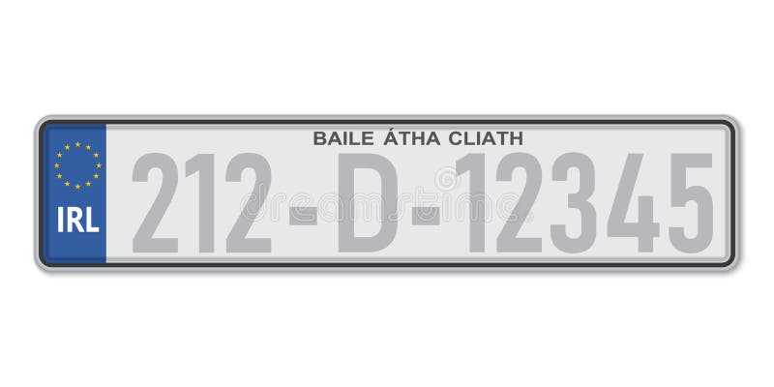

The year indicator is placed first. Current number plates utilize a three-digit format where the first two digits indicate the year and the last digit indicates the year half.

For example, 241 represents a vehicle registered in the first half of 2024, 242 represents a vehicle registered in the second half of 2024.

Following the year indicator is the county designation. County designations can be either one or two digits long depending on the locale: for example D for Dublin, CN for Cavan.

These marks are separated by hyphens rather than spaces. At the end of the plate is anywhere between **one to six digits** which are specific to the vehicle in the order that it was registered in.

Valid Registrations include 181-D-123456, 182-CN-1234, 241-L-12, 232-WW-1

1. Create a class called CarRegistration which sets the registration number in the constructor. Create a validation method which uses a regular expression to validate the incoming registation number. If the number is valid, set the registration to the incoming value. If the numer is invalid, set the registration to “N/A”. For test purposes, valid counties are D, L, RN and SO

(15 marks)

1. Write the appropriate number of units tests for your validation method.

(15 marks)

(Total 30 marks)